Iowa Racquetball Association

Executive Board Meeting Agenda, June 3, 2013

*\* This is a combined Agenda/Minutes document.*

*Blue text in indicates minutes.*

*Red text indicates action items to be completed before next meeting.*

PRESENT: JOE WILLIAMS, DON SHOPIERAY, DON MCCORMICK

* Welcome USAR participants
  + Don Schopieray & Joe Williams
* Housekeeping
  + Approval of May 20 meeting minutes
* Budget Summary
  + Update from Josh
  + Status of $1,000 from Sports Commission
* Lunches for Junior Nationals
  + Update from Don S or Joe on contributions by other state associations and national stakeholders
    - Don S reported on his efforts to get sponsorships for lunches from other state associations.
      * Commitments: MI $300, TX $300, IRT $250, CO $300, CA likely $300 (remainder of their budget for sending juniors to DSM)
      * Requested yet uncommitted: IL $300 IRT Network $250
    - Don S recommended someone from IRA call the contacts in the committed and uncommitted states/organizations to show our appreciation and seal the deal. This would include making sure that we arrange interviews on the IRT Network.
      * Bryan offered to make these calls.
    - Don S said he thinks he can lean on a few more states/organizations for additional donations.
    - Don S will arrange banners noting those who have donated to each lunch. He’ll send a mock-up to Don and Denny for review and approval.
    - Regarding volunteer shirts, Don S reported that Jon Clay is giving USAR a good price. IRA needs to come up with the design and work directly with Jon. We also have to run the design by USAR. This needs to happen in the next week or two. It should include: USAR logo, Wilson, Rollout Racquetball, the word “VOLUNTEER,” the IRA logo, & Penn. Jon should have most of the logos. The group discussed orange as a color.

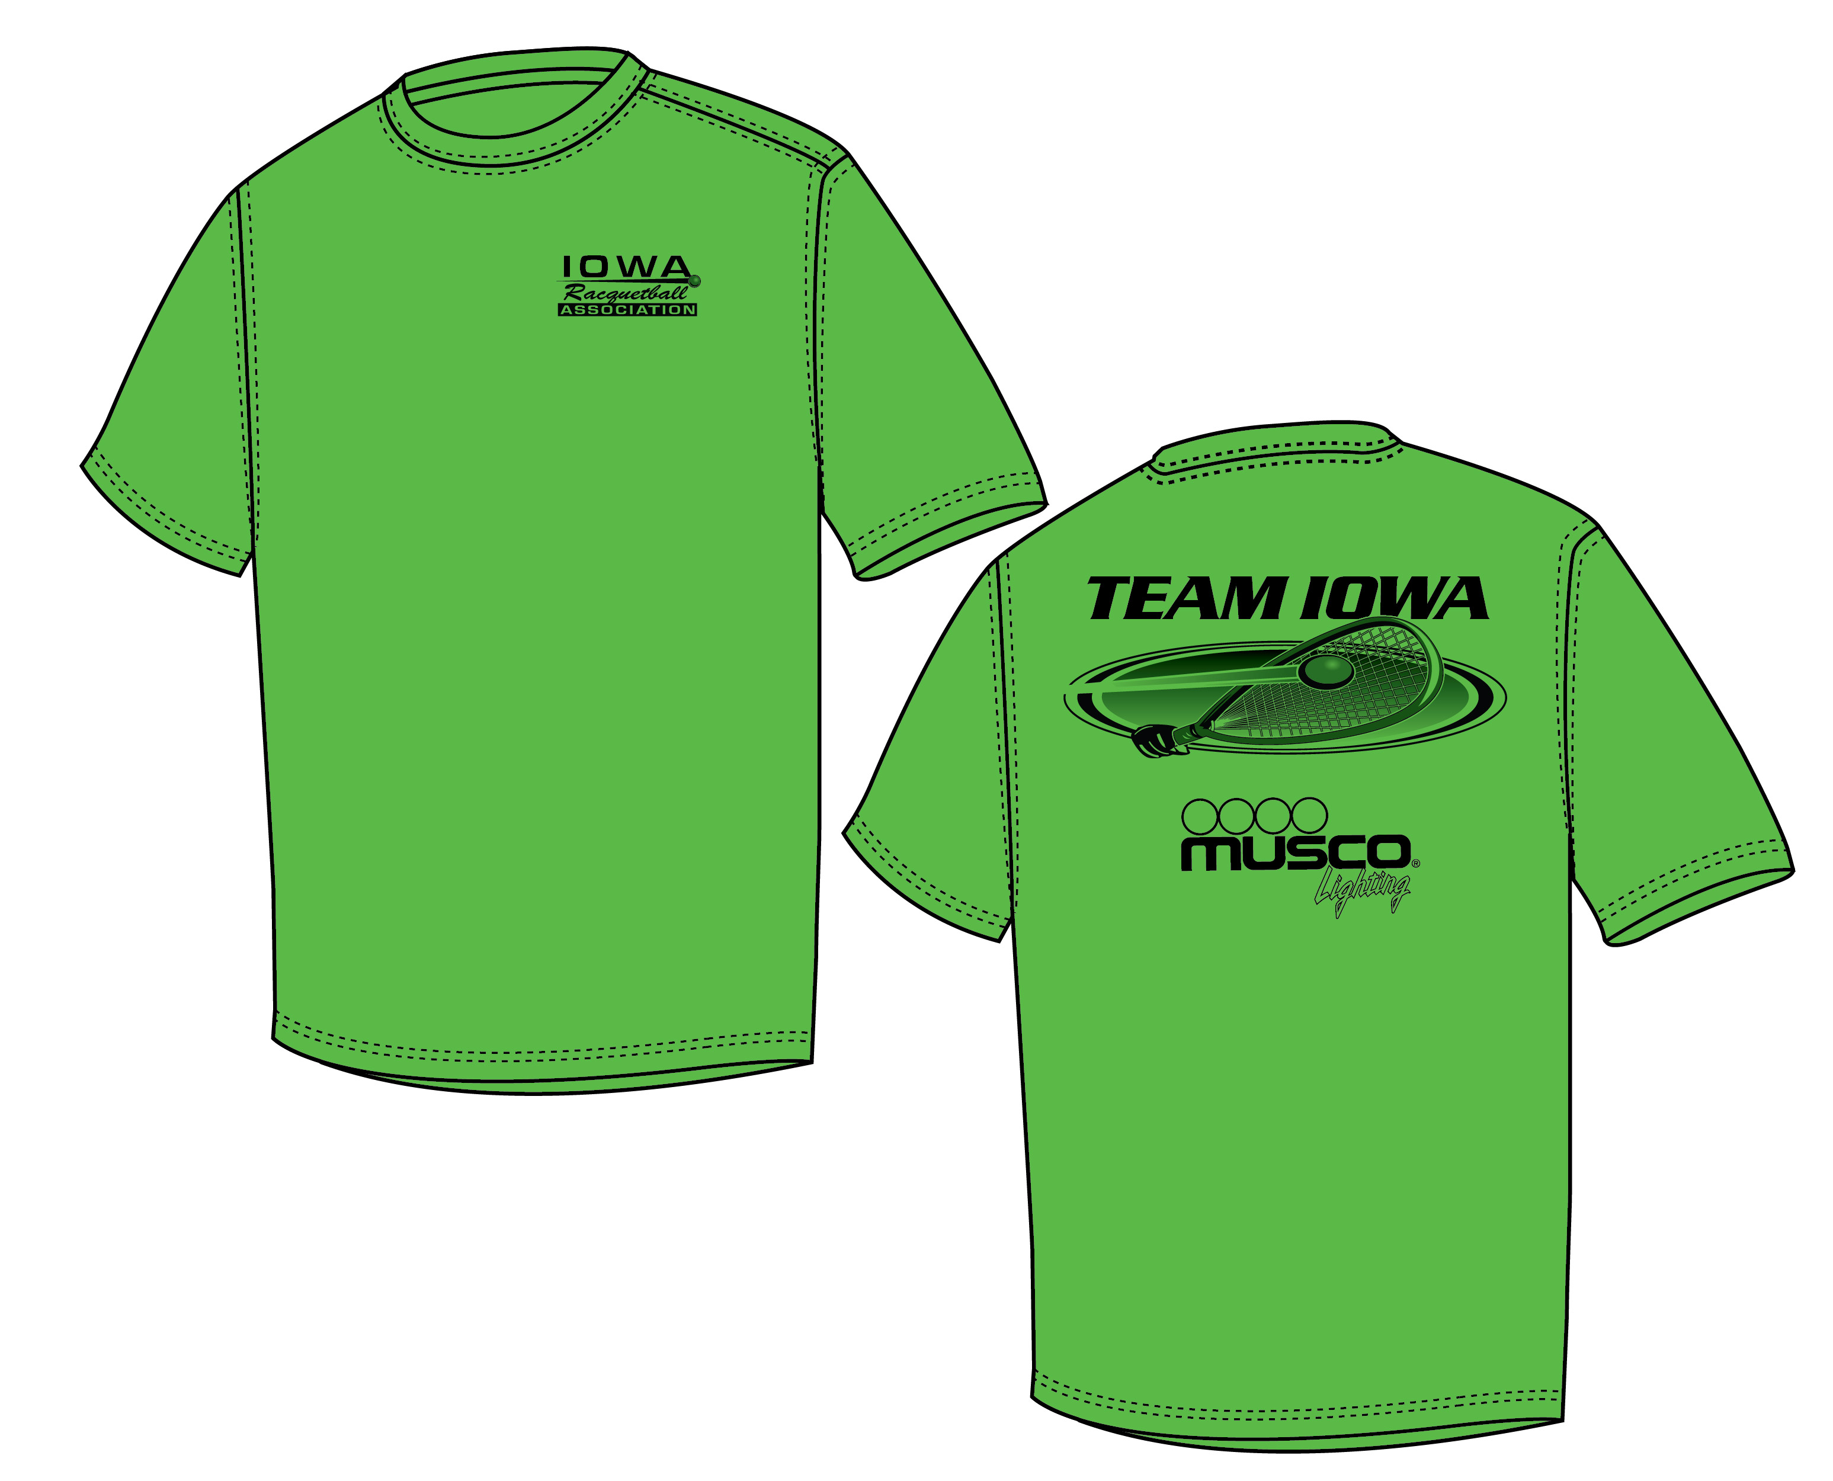

* + - * Don will work on the design.
      * Bryan will take the lead in speaking to Jon. Don S will talk to Jon to let him know that Bryan will be in touch and to work out the payment details.
    - Team Iowa shirts can include any logos we want. Don McC reported that the mock-up we have received from Musco is green. See embedded image here.
    - Joe reported that the color for this year’s tournament shirt for players has not been decided.
    - Joe says someone from the Des Moines Sports Commission will be at the event with a table. Joe is working with Scott on the details.
    - The new parent welcome event, referee clinic, and banquet will be handled by the USAR Junior Committee. The committee will be handling some other responsibilities too. Don S will send the schedule and details to Don McC once they are set.
    - Jim will be running the actual tournament and manning the tourney desk. Steve is coming Friday and Saturday.
    - Bryan asked whether we might have a chance to host consecutive years. Don S said this event may return to Des Moines, but he doesn’t see it happening in 2014; USAR has already entered into negotiations with another location.
  + Update from Robin, via Bryan – This section was tabled for next meeting.
  + Menu / Ingredient List from Oakmoor – This section was tabled for next meeting.

|  |  |  |  |  |
| --- | --- | --- | --- | --- |
| **Wednesday, 6/26** | **Thursday, 6/27** | **Friday, 6/28** | **Saturday, 6/29** | **Sunday, 6/30** |
| **Sandwiches**   * Lunchmeat (e.g., turkey, ham) 3 oz. each * Cheese (e.g., Provolone, Colby Jack) * Condiments (e.g., mayo, mustard) * Buns * Chips * Carrots * Cookies | **Pizza**   * Cheese * Ground beef * Pepperoni * Pizza sauce * Apples or Bananas * Cookies | **Grilled Food**   * Hamburger patties or hot dogs * Buns * Condiments * Cheese * Chips * Watermelon * Cookies | **Walking Tacos**   * Ground beef (4 oz each) * Taco seasoning * Snack-sized bags of nacho chips * Sour cream * Shredded mild cheddar cheese * Carrots * Cookies * Plastic spoons or forks | **Sandwiches**   * Lunchmeat * Cheese * Condiments * Buns * Chips * Carrots * Cookies |

* Fundraising
  + Bryan: Racquetball Warehouse, Alan Fender, Rosco, CFO of Musco Lighting, Panchero’s, Bennegan’s, Bandit Burrito
    - Fender = not sure; Musco = shirts is the contribution; Racquetball Warehouse = sent e-mail but suspects they may be unable to help since they helped with Iowa Open; Ektelon = sending goodies for volunteers. Bryan has yet to follow up on the other contacts listed above.
    - Bryan says he thinks it’s worthwhile considering catering donations in addition to cash. The board agreed.
  + Rob: Head Racquetball, Coldstone, Wendy’s, Chicago Pizza, Sonic, Pagliais's Pizza
    - Head = goodies for volunteers; Old Chicago = will get word tomorrow; Pagliai’s Pizza = will get word tomorrow; Coldstone, Wendy’s, and Sonic = under consideration
  + Denny: Hy-Vee In Johnston, Buffalo Wild Wings, Subway, Jimmy John’s
    - Johnston Hy-Vee = might contact Denny tomorrow; Buffalo Wild Wings = coupons maybe, but Denny will follow up; Jimmy Johns = Denny will go to corporate office to make our case. Subway = haven’t called Denny back.
  + Susan: Green Briar, McDonald’s, Ramada Inn Restaurant
    - No report.
  + Josh: Datonya’s, Applebee’s, Okoboji, Chipotle, Perkins
    - Sent following report: “I contacted Perkins, Daytona’s, Applebee’s, Chipotle, Perkins and Okoboji Grille. Perkins said no. Daytona’s & Applebee’s I have to contact later in the week to speak with the general manager. Chipotle said they can give 10 fee burrito coupons, but that is the most they could offer. I told them I would speak with the board but we were looking for something more substantial.”
  + Don: MidAmerican Energy, Nationwide, HyVee Urbandale, Dahl’s, Jordan Creek Mall, Science Center, Blank Park Zoo, Living History Farms, Iowa Speedway, Adventureland, Carmike Theaters, Bass Pro Shops, Chris Zwilling (Wells Fargo), Famous Dave’s, Legends, Incredible Pizza
    - See embedded tracking document here.



* + - Don reported that he also has asked other non-board members to work their contacts to get donations, including Hy-Vee in WDM (via Dan Horner) and Marel Townsend (via Chris Ellis)
  + Joe says it might be worthwhile to piggyback a charity.
    - Bryan recommended David’s Fight.
      * Denny asked whether that would benefit Oakmoor.
    - The group discussed citing the charity as “a local playground.” The beneficiary would be the Oakmoor daycare.
      * The motion was carried
* Ancillary donations – This section was tabled for next meeting.
  + Breakfast foods
  + Fruit
  + Gatorade
* Vendor Options – This section was tabled for next meeting.
  + Have board members thought more about this and if so, which vendors should we invite?
* Team Iowa – This section was tabled for next meeting.
  + Shirts
* Event Promotion – This section was tabled for next meeting.
  + New Mail Chimp account
  + Facebook pages
  + Reaching out to Pros
* Fall IRA Tournament – This section was tabled for next meeting.
  + Proposed dates
* Next meeting
  + Proposed date?
    - Monday 6/10 8:00
* Other items
  + Bryan recommended we also try to raise money for the US Team, especially when talking to Iowa racquetball members.
  + Joe reported that Scott from the Sports Commission has committed to getting coupons from businesses for his booth.